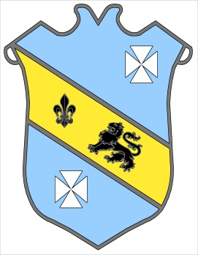 | Bruff RFC  Underage Rugby Club  Kilballyowen, Bruff, Co. Limerick
Get Ready For The New Season

Registration For the 2016 - 17 Season
All Mini & Youth Rugby
NEW Members Welcome

Sunday 4th September 2016

Sign Up on the Day - From 10:15 am

Mini Rugby: 10:30 am, Ages 6 – 12 Years

Youth Rugby: 11:30 am, Ages 13 – 18 Years

For Membership Details Contact

086-8212326/086-8030037/087-9090461

www.bruffrfc.com
www.facebook.com/bruff.rfc

