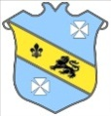 | Bruff RFC Underage Rugby Match Fixtures 2015 - 2016
Age Grade |  | Date | Home Team |  | Away Team | Venue |  | Time
Under 18 |  | 6 March 2016 | Bruff RFC | V | Dolphin RFC | Kilballyowen |  | 12:00
Under 16 |  | 5 March 2016 | Bandon RFC | V | Bruff RFC | Bandon |  | 13:30
Under 14 |  | 6 March 2016 | Bruff RFC | V | Ennis RFC | Kilballyowen |  | 11:30

