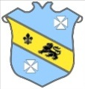
Bruff RFC Underage Rugby Match Results 2015 - 2016
Age Grade | Date | Bruff RFC | Score | Opposition | Score | Venue
Under 14 | 21 February 2016 | Bruff RFC | 0 | Garryowen RFC | 21 | Dooradoyle
Under 13 | 21 February 2016 | Bruff RFC | 0 | Garryowen RFC | 17 | Kilballyowen

