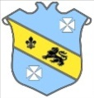 | Bruff RFC Underage Rugby Match Fixtures 2015 - 2016
Age Grade |  | Date | Home Team |  | Away Team | Venue |  | Time
Under 14 |  | 7 February 2016 | Bruff RFC | V | Ennis RFC | Kilballyowen |  | 11:30
Under 13 |  | 7 February 2016 | Bruff RFC | V | Garryowen RFC | Kilballyowen |  | 12:00

