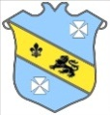 | Bruff RFC Underage Rugby Match Fixtures 2015 - 2016
Age Grade |  | Date | Home Team |  | Away Team | Venue |  | Time
Under 15 |  | 21 February 2016 | Bruff RFC | V | Abbeyfeale RFC | Kilballyowen |  | 12:00
Under 14 |  | 21 February 2016 | Garryowen | V | Bruff RFC | Dooradoyle |  | 12:30
Under 13 |  | 21 February 2016 | Bruff RFC | V | Garryowen RFC | Kilballyowen |  | 12:00

