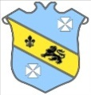
Bruff RFC Underage Rugby Match Results 2015 - 2016
Age Grade | Date | Bruff RFC | Score | Opposition | Score | Venue
Under 18 | 17th January 2016 | Bruff RFC | 16 | Waterpark RFC | 8 | Kilballyowen
Under 16 | 17th January 2016 | Bruff RFC | 22 | Ballincollig RFC | 0 | Kilballyowen
Under 15 | 17th January 2016 | Bruff RFC | 7 | Pres-Richmond RFC | 19 | Richmond Park

