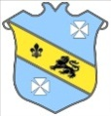 | Bruff RFC Underage Rugby Match Fixtures 2015 - 2016
Age Grade |  | Date | Home Team |  | Away Team | Venue |  | Time
Under 15 |  | 08 January 2016 | Bruff RFC | V | Thomond RFC | Kilballyowen |  | 19:30
Under 16 |  | 10 January 2016 | Bruff RFC | V | Nenagh Ormond RFC | Nenagh |  | 11:30
Under 14 |  | 10 January 2016 | Bruff RFC | V | Richmond RFC | Richmond Park |  | 11:00

