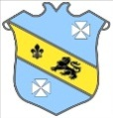 | Bruff RFC Underage Rugby Match Fixtures 2015 - 2016
Age Grade |  | Date | Home Team |  | Away Team | Venue |  | Time
Under 18 |  | 17 January 2016 | Bruff RFC | V | Waterpark RFC | Kilballyowen |  | 13:00
Under 15 |  | 17 January 2016 | Bruff RFC | V | Ballincollig RFC | Kilballyowen |  | 12:30
Under 15 |  | 17 January 2016 | Richmond RFC | V | Bruff RFC | Richmond Park |  | 12:15

