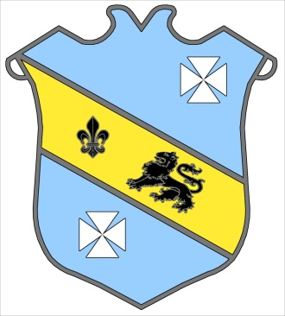 | Bruff RFC  Underage Rugby Club  Kilballyowen Park,  Bruff  Founded 1970

Fundraiser for Underage Tour to

Manchester 2016 March 24th

Underage Rugby Used Clothes Collection

Bring Along the following items of Clothing in Bags
to the Designated Drop Off Point

- Old Clothes
- Pairs of Shoes
- Belts
- Handbags

Please Bring Along and Donate for January and February 2016 – All Funds Collected Go Towards the Underage Tour

Thanks for your Continued Support

