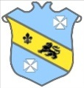 | Bruff RFC Underage Rugby Match Fixtures 2015 - 2016
Age Grade |  | Date | Home Team |  | Away Team | Venue |  | Time
Under 16 |  | 12 December 2015 | Bruff RFC | V | Cobh Pirates RFC | Cobh |  | 12:30
Under 18 |  | 13 December 2015 | Bruff RFC | V | Highfield RFC | Kilballyowen |  | 12:30
Under 14 |  | 13 December 2015 | Bruff RFC | V | UL Bohs RFC | Kilballyowen |  | 12:00

