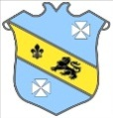
Bruff RFC Underage Rugby Match Results 2015 - 2016
Age Grade | Date | Bruff RFC | Score | Opposition | Score | Venue
Under 16 | 8th November 2015 | Bruff RFC | 25 | Young Munster RFC | 3 | Kilballyowen
Under 15 | 8th November 2015 | Bruff RFC | 0 | Young Munster RFC | 26 | Derryknockane
Under 13 | 8th November 2015 | Bruff RFC | 5 | Garryowen RFC | 20 | Kilballyowen

