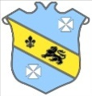 | Bruff RFC Underage Rugby Match Fixtures 2015 - 2016
Age Grade |  | Date | Home Team | V | Away Team | Venue |  | Time
Under 16 |  | 08 November 2015 | Bruff RFC | V | Young Munster RFC | Kilballyowen |  | 12:00
Under 15 |  | 08 November 2015 | Young Munster RFC | V | Bruff RFC | Derryknockane |  | 12:00
Under 13 |  | 08 November 2015 | Bruff RFC | V | Garryowen RFC | Kilballyowen |  | 12:00

