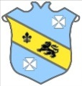 | Bruff RFC Underage Rugby Match Fixtures 2015 - 2016
Age Grade |  | Date | Home Team | V | Away Team | Venue |  | Time
Under 18 |  | 29 November 2015 | Bruff RFC | V | Young Munster RFC | Kilballyowen |  | 12:00
Under 14 |  | 29 November 2015 | Kilrush RFC | V | Bruff RFC | Kilrush |  | 12:00

