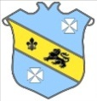 | Bruff RFC Underage Rugby Match Fixtures 2015 - 2016
Age Grade |  | Date | Home Team | V | Away Team | Venue |  | Time
Under 18 |  | 15 November 2015 | Bruff RFC | V | Tralee RFC | Kilballyowen |  | 12:00
Under 15 |  | 15 November 2015 | Bruff RFC | V | Old Crescent RFC | Kilballyowen |  | 12:30
Under 14 |  | 15 November 2015 | Bruff RFC | V | Ballina/Killaloe RFC | Kilballyowen |  | 11:30

