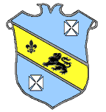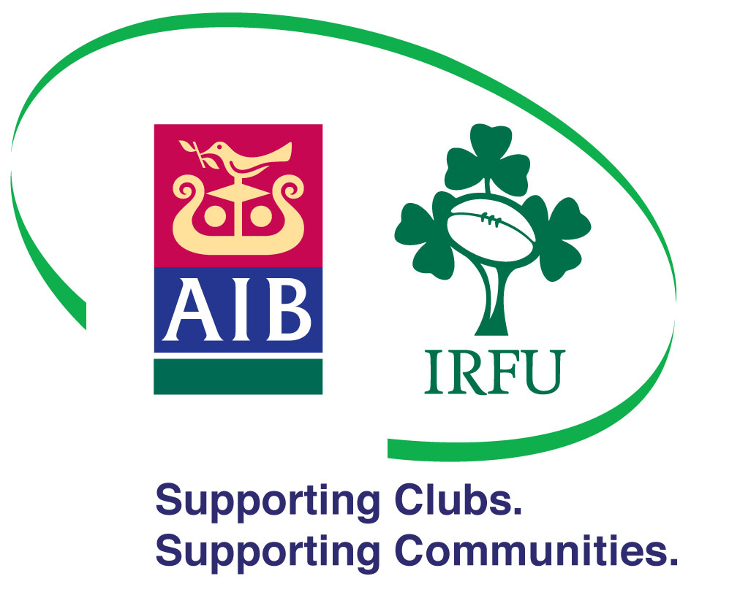
Bruff Underage Rugby.

Kilballyowen Park, Bruff, Co. Limerick.
Founded 1970

Club Telephone: 061-382372
Youth Player Registration Form

Please fill in using Block Capitals Only.

First Name_____________________________ Surname:__________________________________

Date Of Birth: __________________________ Phone Number:_____________________________

Home Address: ______________________________________________________________________

____________________________________________________________________________________

Parent/Guardian Name: _______________________________________________________________

Home Phone:___________________________ Work Phone:_______________________________

Mobile Number:________________________ Email Address: _____________________________

School Attended:______________________________________________________________________

Please Note: any relevant medical information to be passed on to team coach.

Form must be returned to the team coach with a €10.00 registration fee enclosed.
For Official Use Only:

Current Season:_______________________ Age Grade:____________________

Jerseys (€55.00) and Socks (€9.00) are available at the club shop.

